Q1 Lynda Course Completions – 13 hours, 493 minutes, 180 seconds – 21 hours, 16 minute, 0 seconds

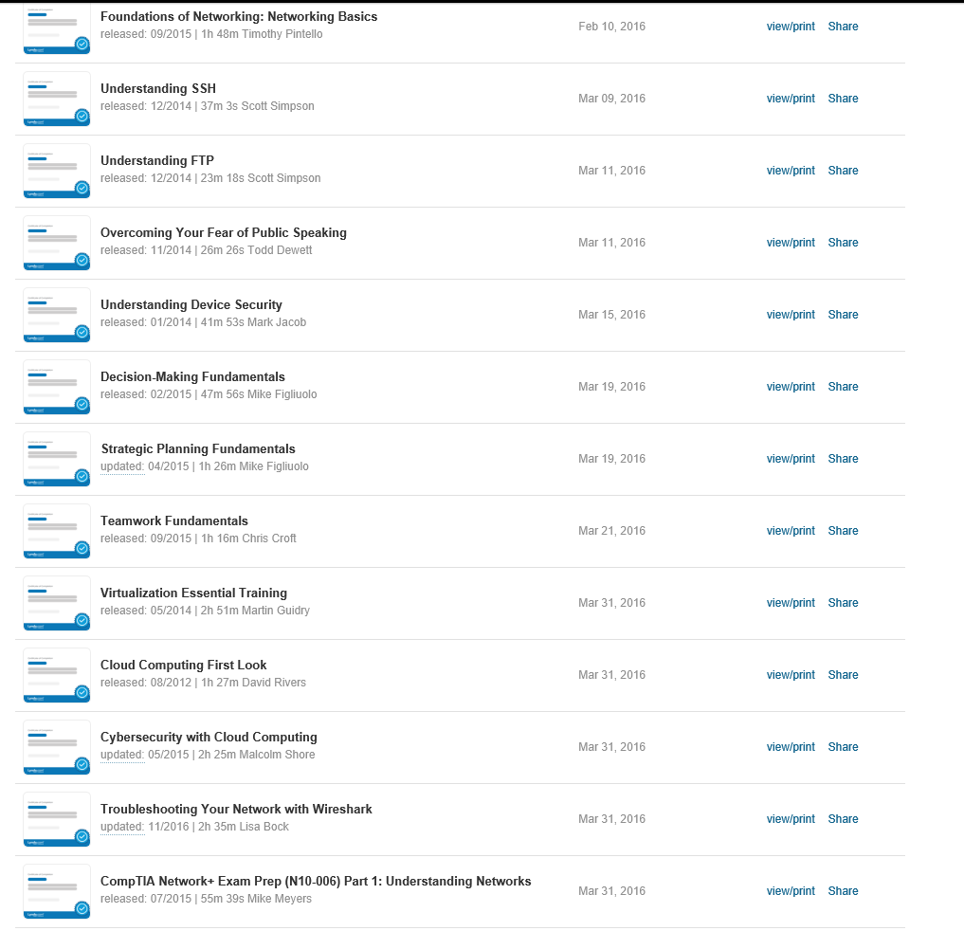

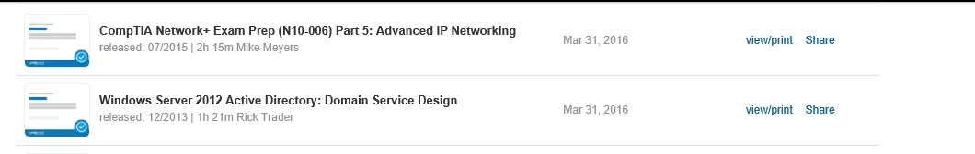

Q2 Lynda Course Completions – 63 hours, 852 minutes, 0 seconds – 77 hours, 12 minutes, 0 seconds

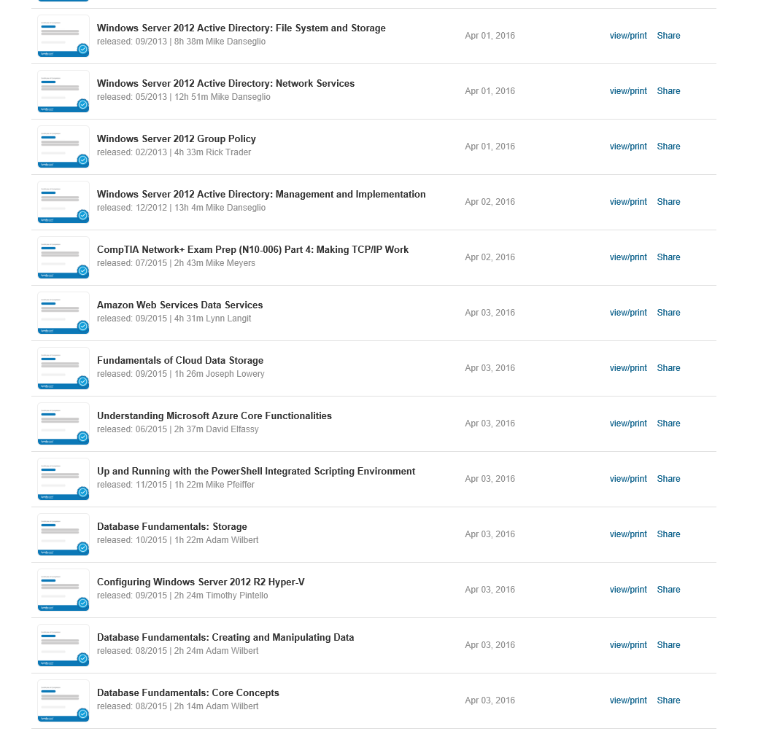

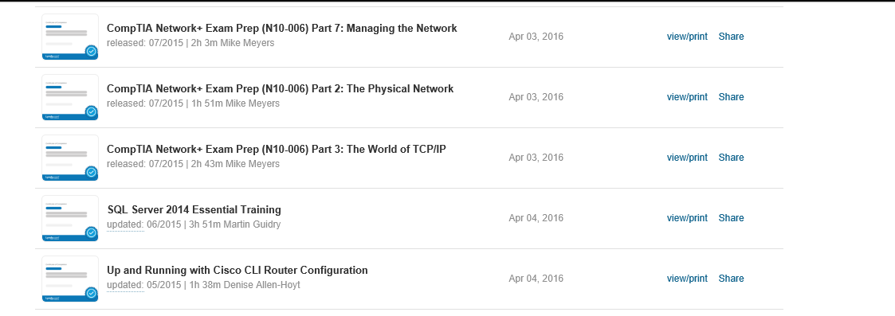

Q3 Lynda Course Completions – 38 hours, 697 minutes, 72 seconds – 49 hours, 38 minutes, 12 seconds

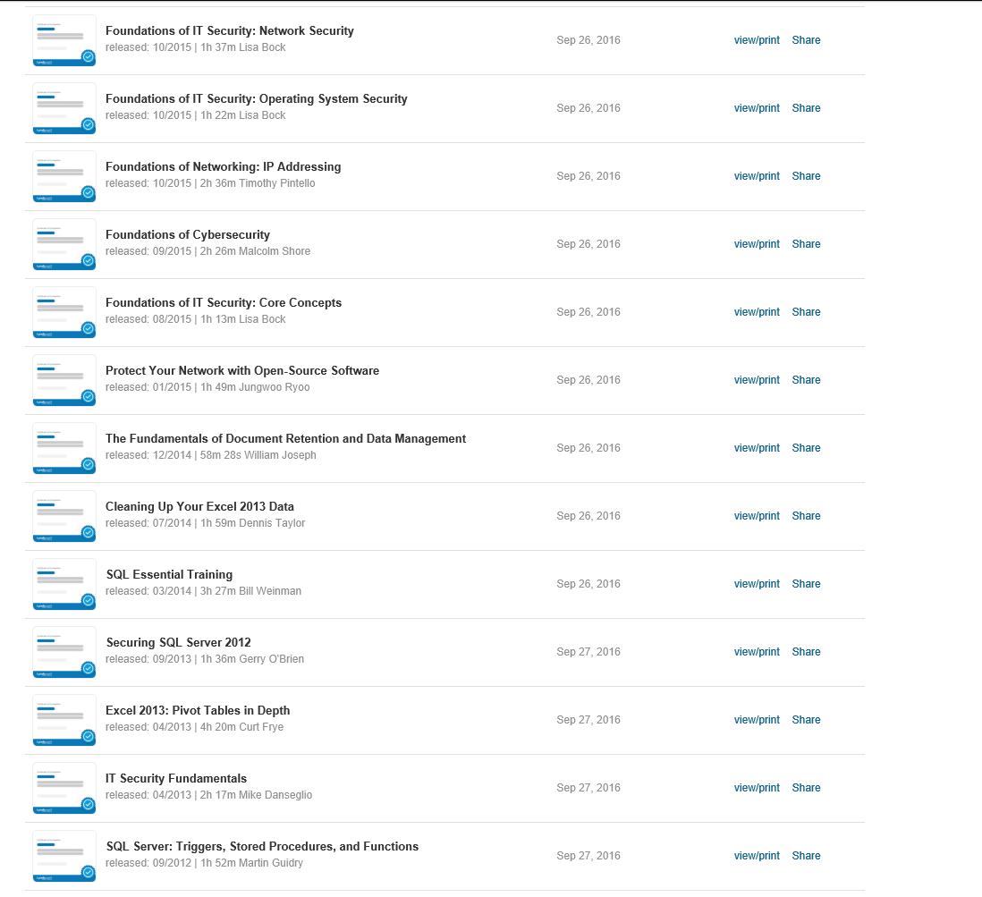

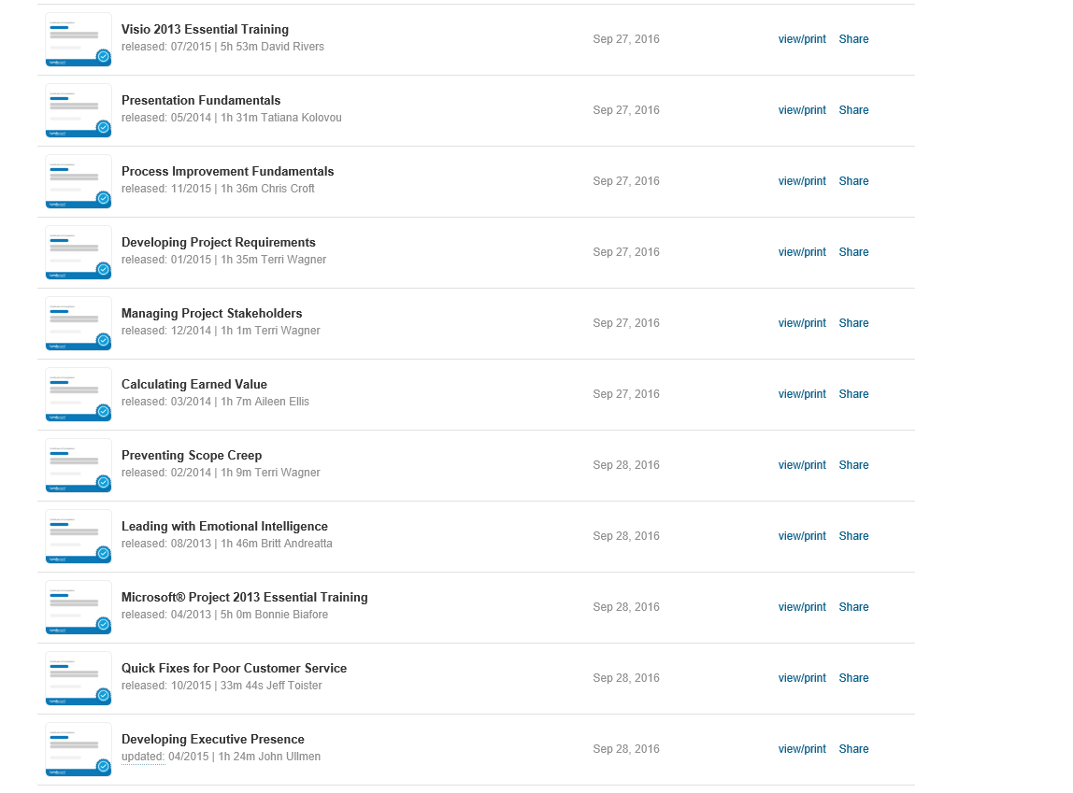

Q4 Lynda Course Completions – 2 hours, 118 minutes, 40 seconds – 3 hours, 58 minutes, 40 seconds

